SIMATS ENGINEERING (SAVEETHA SCHOOL OF ENGINEERING)
Department of Computer Science and Engineering

CO5 - ASSESSMENT TOOL 2 – Coding Challenge

Course Code: | DSA0404 | Course Title: | FUNDAMENTALS OF DATA  SCIENCE
CO Assessed: | CO5 –Coding Challenge | Assessment: | Assessment Tool 2– Coding Challenge
Weightage: | 40% of CIA | Total Marks: | 100
CO5 Statement: | To understand the concept of supervised and unsupervised methods in machine learning
Student Name: | T.Chandana | Reg. No.: | 192472059
Section / Batch: | 2024 | Date: | 26-08-2026

Code of Conduct
I _ T.Chandana _(192472059)_ (Name / Reg No) certify that this submission is my original work and that I have adhered to the guidelines specified for this assessment. I understand that any violation of academic integrity rules will result in disciplinary action.
Signature of the Student: _ T.Chandana ________________________

Criteria | Weight age | Level 4 – Exemplary | Level 3 – Proficient | Level 2 – Developing | Level 1 – Beginning | Marks
Understanding of Case | 25 | Thorough  understanding; clearly identifies all key issues | Good understanding with most issues identified | Basic understanding; some issues missed | Poor understanding; problem not identified correctly
Application of Concepts | 25 | Effectively applies relevant concepts to analyze the case deeply | Applies appropriate concepts with minor gaps | Limited application of concepts | Fails to apply relevant concepts
Analysis | 20 | In-depth analysis with strong reasoning and insights | Good analysis with logical reasoning | Basic analysis with limited depth | Weak or no analysis; lacks reasoning
Solution Design | 20 | Innovative, feasible solutions with strong justification | Logical solutions with  adequate  justification | Basic solutions with weak justification | Incorrect or no solution provided
Clarity | 10 | Clear, well-structured, and easy to understand | Organized and understandable presentation | Limited clarity and structure | Poor clarity; difficult to understand

22. Implement binary logistic regression from scratch, including the sigmoid function, binary cross-entropy loss, and gradient descent for parameter updates — nosklearn.linear_model.LogisticRegression. Verify convergence by plotting the log-loss curve.

Source Code:
import numpy as np
import matplotlib.pyplot as plt

# Two input features
X = np.array([
[1, 2],
[2, 1],
[2, 3],
[3, 2],
[4, 5],
[5, 4],
[6, 5],
[7, 6],
[8, 7],
[9, 8]
], dtype=float)

# Target variable
# 0 = Class 0
# 1 = Class 1

y = np.array([
0,
0,
0,
0,
1,
1,
1,
1,
1,
1
], dtype=float)

def sigmoid(z):
return 1 / (1 + np.exp(-z))

# Number of features
number_of_features = X.shape[1]

# Initialize weights with zeros
weights = np.zeros(number_of_features)

# Initialize bias
bias = 0.0

# Learning rate
learning_rate = 0.1

# Number of iterations
iterations = 1000

# Store loss values for plotting
loss_history = []

for i in range(iterations):

# --------------------------------------------------------
# Calculate linear combination
# z = XW + b
# --------------------------------------------------------

z = np.dot(X, weights) + bias

# --------------------------------------------------------
# Calculate predicted probability using sigmoid
# --------------------------------------------------------

y_pred = sigmoid(z)

# --------------------------------------------------------
# Calculate Binary Cross-Entropy Loss
# --------------------------------------------------------

# Small value to avoid log(0)
epsilon = 1e-15

# Keep predictions between epsilon and 1-epsilon
y_pred_clipped = np.clip(
y_pred,
epsilon,
1 - epsilon
)

loss = -np.mean(
y * np.log(y_pred_clipped)
+
(1 - y) * np.log(1 - y_pred_clipped)
)

# Store loss
loss_history.append(loss)

dw = (
1 / len(X)
) * np.dot(
X.T,
(y_pred - y)
)

db = (
1 / len(X)
) * np.sum(
y_pred - y
)

weights = weights - learning_rate * dw

bias = bias - learning_rate * db

# Calculate final linear output
z = np.dot(X, weights) + bias

# Calculate final probabilities
probabilities = sigmoid(z)

# Convert probability into binary class
# Threshold = 0.5
predictions = (probabilities >= 0.5).astype(int)

accuracy = np.mean(predictions == y.astype(int)) * 100

print("==============================================")
print("BINARY LOGISTIC REGRESSION FROM SCRATCH")
print("==============================================")

print("\nFinal Weights:")
print(weights)

print("\nFinal Bias:")
print(bias)

print("\nPredicted Probabilities:")

for i in range(len(X)):
print(
"Data Point", i + 1,
"-> Probability:",
round(probabilities[i], 4)
)

print("\nPredicted Classes:")
print(predictions)

print("\nActual Classes:")
print(y.astype(int))

print("\nFinal Binary Cross-Entropy Loss:")
print(round(loss_history[-1], 6))

print("\nAccuracy:")
print(round(accuracy, 2), "%")

print("\nInitial Loss:")
print(round(loss_history[0], 6))

print("\nFinal Loss:")
print(round(loss_history[-1], 6))
plt.figure(figsize=(8, 5))

plt.plot(
range(1, iterations + 1),
loss_history
)

plt.xlabel("Iterations")
plt.ylabel("Binary Cross-Entropy Loss")

plt.title(
"Log-Loss Curve for Logistic Regression From Scratch"
)

plt.grid(True)

plt.show()

OUTPUT:

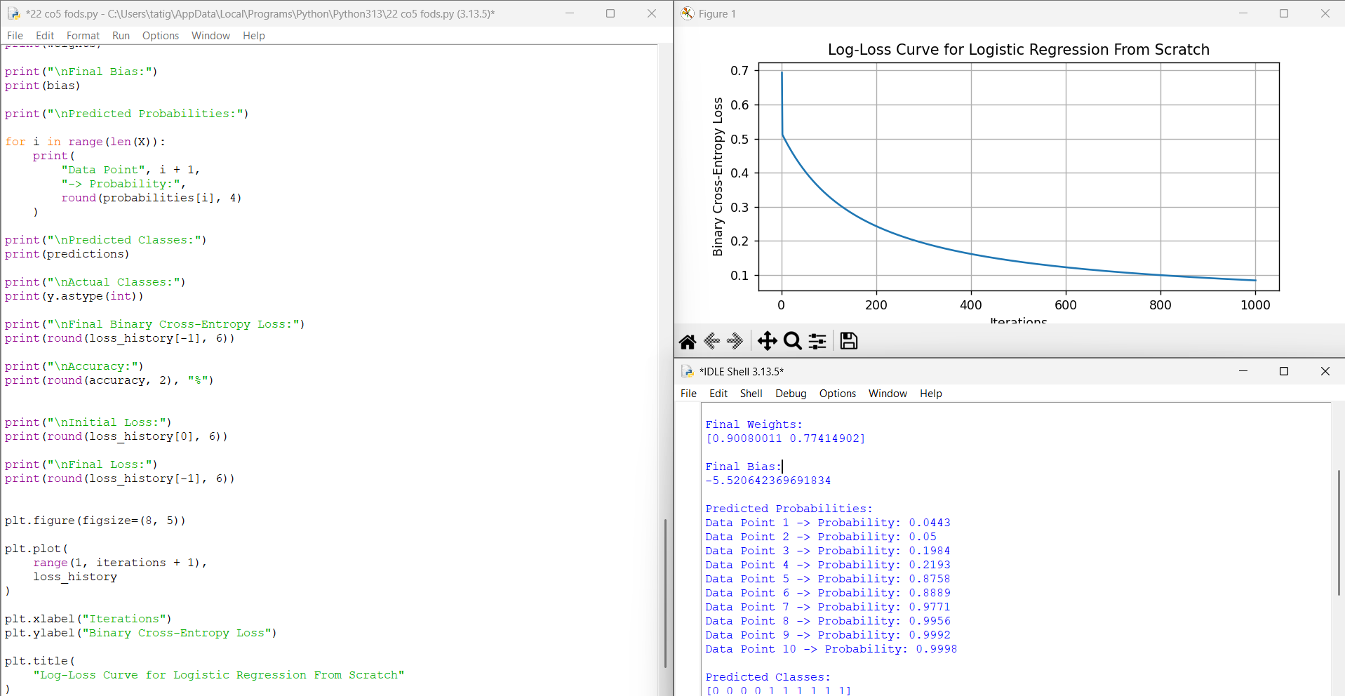

GEO TAG:

